Project Portfolio Creation

Creating a portfolio of projects that you have worked with is very helpful for the employers to see your skills. The recommendation is to start from early in your degree to collect information about the projects that you worked on and by your graduation, you will have a nice portfolio to show the employers or interviewers.

Here are some items that you can consider to put in your portfolio for each course project:

* The abstract of the project
  + Include the course number and name
  + Include a short description of the project
  + Include the analysis methodologies used
  + Include the programming language used
  + Include the transferrable skills practiced (e.g., presentation skills, writing skills, time management skills, team-work skills, leadership skills, self-learning skills etc.)
  + Include the importance/significance of the project if possible
* Final product of the project if it is an oral presentation
  + Include the slides of the presentation
  + Include any evidence of working with other people (like a peer review)
* At the end of each semester, always take a look back at the previous projects and briefly add:
  + What could be done differently to make the project better? Is there any different approach to the project to make the results more accurate?
  + What could be the next step(s) of this project?

Make your portfolio available on GitHub. Here are the instructions of creating a repository on GitHub:

* Go to <https://github.com/>
* Sign up an account by clicking on the top right corner; Then enter your email, password, username and follow the steps to create your account.

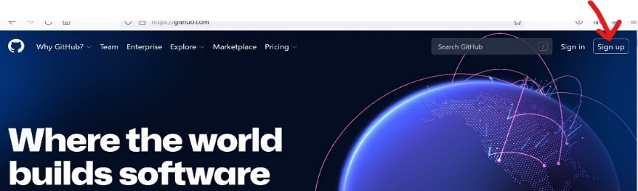

* Click on “Create repository” on the left panel, and follow the steps to create the repository. One recommendation is to check the Add a README file so the audience understand what’s included, and check “Private” to ensure some data privacy.

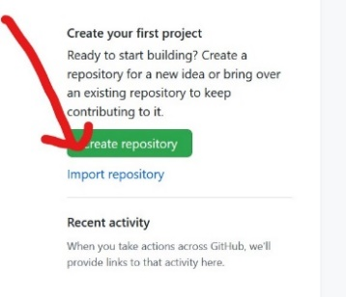

* Click Add file to upload files from your computer, and click “commit changes” after uploading.

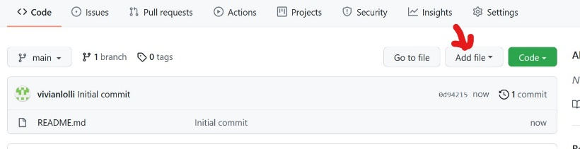

* If you would like to share your repository with an employer, click “Settings” on the top panel.

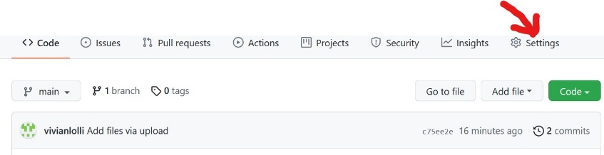

* Click “Manage access” from settings.

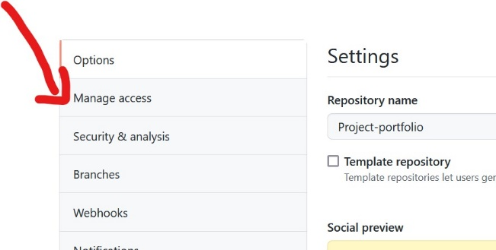

* Click “Add people” and add your collaborator or employer’s email to share your files.

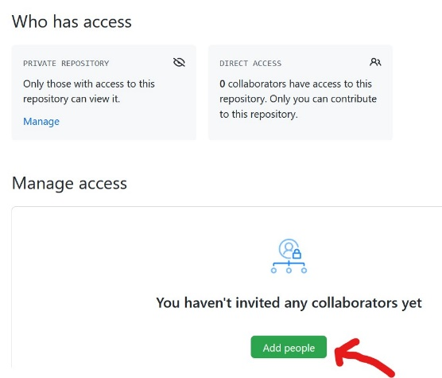

For more detailed information of how to create and maintain a repository on GitHub, please refer to chapter 6.3 of the open resource book Pro Git by Scott Chacon and Ben Straub (<https://git-scm.com/book/en/v2/GitHub-Maintaining-a-Project> ), licensed under the [Creative Commons Attribution Non Commercial Share Alike 3.0 license](https://creativecommons.org/licenses/by-nc-sa/3.0/).